|  |  |
| --- | --- |
|  | **Year 11 ATAR Human Biology**  **Task 8 – DNA and cell reproduction** |

|  |  |  |  |
| --- | --- | --- | --- |
| **Name: ANSWERS** | **Teacher:** | **Date:** | **Score: /57** |

**Assessment type:** Test

**Conditions**

Time for the task: 55 minutes

**Task weighting** – 5%

Total marks 57

______________________________________________________________________________

**Section 1: Multiple-choice (10 marks)**

This section has 10 questions. Answer all questions by writing the letter corresponding to the correct answer in the box provided.

1. The diagram below shows a section of DNA undergoing replication.

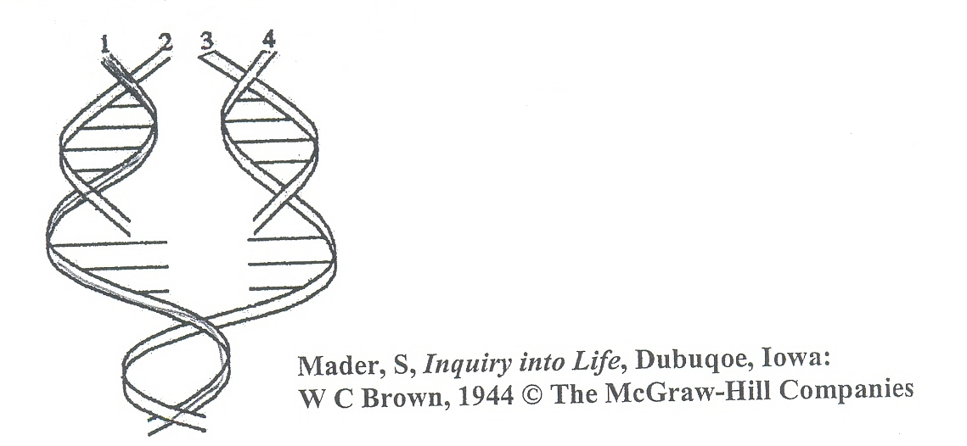

Which two strands of DNA would the sequence of bases be the same?

1. 1 and 4.
2. 2 and 3.
3. 3 and 4.
4. **2 and 4.**
5. Which of the following statements regarding DNA replication is true?
6. DNA replication does not require enzyme activity.
7. The ribosomes carry out DNA replication.
8. **The process of DNA replication occurs in the nucleus of the cell.**
9. DNA replication is the major process by which genes are rearranged along a chromosome.
10. The enzyme responsible for making the double stranded DNA molecules come apart during transcription is
11. amylase.
12. polymerase.
13. **helicase.**
14. protease.
15. RNA molecules have the base uracil instead of
16. guanine.
17. **thymine.**
18. adenosine
19. none of the above.
20. Altering the expression of a gene without changing the gene structure is called
21. transcription.
22. translation.
23. gene expression.
24. **epigenetics.**
25. Examples of environmental agents that may cause epigenetic changes are
26. severe stress.
27. nutritional factors.
28. drugs.
29. **all of the above.**
30. DNA codes for the sequence of amino acids in a protein. The diagram below shows a section a DNA strand.

Using the base pair rule, which of the following shows the correct complimentary DNA strand?

1. ATGTCCCCCT
2. UCGTCCCCCU
3. **ACGTCCCCCT**
4. GCTGCCCCCG
5. If prophase is the beginning what is the end of cell division?
6. **Telophase.**
7. Metaphase.
8. Interphase.
9. Anaphase.
10. The attachment of acetyl molecules to the histones:
11. makes it harder for gene reading mechanisms to access genes.
12. **makes it easier for gene reading mechanisms to access genes.**
13. reorganises the sequence of genes.
14. assists methyl molecules to attach to DNA.
15. Embryonic stem cells are cultured from:
16. red blood cells.
17. blood of the placenta.
18. blood of the umbilical cord.
19. **inner cell mass of the blastocyst.**

**End of Section 1 – Turn over for Section 2**

**Section 2: Short answer (35 marks)**

This section has three questions. Answer all questions. Write your answers in the spaces provided.

______________________________________________________________________________

**Question 11 (4 marks)**

The copy of the genetic code that leaves the nucleus is read by the ribosomes. The table below allows this copy of this code to be read and will describe the sequence of the amino acids in the protein produced.

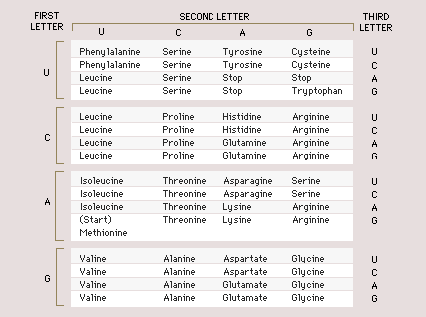

1. What would the amino acid sequence be if the code exiting the nucleus was

**5’AUGGAGUUACAC 3’**

|  |  |
| --- | --- |
| **Description** | **Marks** |
| Methionine, glutamate, leucine, histidine | 1 |
| **Total** | **1** |

1. Carrier molecules bring the amino acids to the ribosome to allow protein synthesis to be completed. Answer the following questions about this process.
2. What is the name of the carrier molecule?

|  |  |
| --- | --- |
| **Description** | **Marks** |
| tRNA | 1 |
| **Total** | **1** |

1. Halfway along the length of the chain of nucleotides of this carrier molecule is a tight loop. What do the three nitrogen bases that are found here form, which can bind with the complementary bases of a codon on the mRNA molecule?

|  |  |
| --- | --- |
| **Description** | **Marks** |
| Anticodon | 1 |
| **Total** | **1** |

1. What happens to the carrier molecule after it has delivered the amino acid to the ribosome?

|  |  |
| --- | --- |
| **Description** | **Marks** |
| Free to collect another of the same amino acid | 1 |
| **Total** | **1** |

**Question 12 (4 marks)**

The diagram below shows the structure of a tRNA molecule.

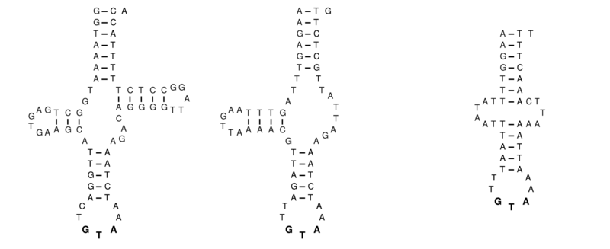

1. Explain the structure of the tRNA molecule that gives it this specific shape.

|  |  |
| --- | --- |
| **Description** | **Marks** |
| Bases bonded/paired by Hydrogen bonds | 1 |
| Complementary base pairing / AU and GC | 1 |
| Loops / clover leaf shape have no bonds / not complementary | 1 |
| **Total** | **3** |

1. Describe one structural difference between mitochondrial DNA and nuclear DNA.

|  |  |
| --- | --- |
| **Description** | **Marks** |
| Any one from the following:   * mtDNA = Small circular molecules rather than nuclear DNA = long chains * Contains one chromosome rather than 46 * Only has 37 genes compared with 100 000s/few compares to 100 000s * Has one heavy strand and one light strand of the helix compared to relatively even strands | 1 |
| **Total** | **1** |

**Question 13 (5 marks)**

Occasionally cells can become abnormal, invading and damaging the tissues of the body. These diseases can be diagnosed as cancer.

1. Describe how cancer develops and suggest one way it can spread throughout the body (metastasise).

|  |  |
| --- | --- |
| **Description** | **Marks** |
| Uncontrolled/excessive division of cells/mitosis | 1 |
| Forms a mass of cells/tumours | 1 |
| Cancerous/abnormal cells travel through lymph/circulatory system | 1 |
| **Total** | **3** |

1. State two ways that you can reduce the risk of getting cancer later in life.

|  |  |
| --- | --- |
| **Description** | **Marks** |
| Any two from the following:   * avoid smoking * use sunscreen, sunglasses, long sleeved clothing, shade and hats to reduce exposure to UV radiation (only award 1 mark if three of these are used each as a way) * stay out of direct sunlight between 10am and 3pm * Diet high in fibre and low in fat * Avoid being overweight or obese * Limit alcohol intake * Protective clothing and face mask when handling chemicals such as organic solvents or vinyl chlorides | 1-2 |
| **Total** | **2** |

**Question 14 (18 marks)**

Tim, a 3-year-old, was diagnosed with leukaemia. At birth, his parents had organised for his cord blood to be banked. The doctors used the stem cells within the cord blood to treat Tim.

1. Circle the type of stem cell that is found in the cord blood.

Embryonic Adult

(1 mark)

1. Leukaemia is a cancer in which the bone marrow produces abnormal white blood cells that interfere with the body’s normal blood cells. Describe the process by which the cord blood could be used to treat Tim.

|  |  |
| --- | --- |
| **Description** | **Marks** |
| Stem cells are cultured/grown in nutrient medium | 1 |
| Stem cells made to differentiate into blood cells that Tim requires | 1 |
| These cells are transplanted into Tim | 1 |
| **Total** | **3** |

1. Compare pluripotent and multipotent stem cells.

|  |  |
| --- | --- |
| **Description** | **Marks** |
| Pluripotent – cells of inner cell membrane, give rise to all cells except embryonic (i.e. a new organism) | 1 |
| Multipotent – give rise to cells that have a specific function, e.g. bone marrow cells produce blood cells | 1 |
| **Total** | **2** |

1. Complete the table below, comparing mitosis and meiosis in humans

|  |  |  |
| --- | --- | --- |
| **Description** | | **Marks** |
| Number of cells produced | Mitosis: 2 cells | 1 |
| Meiosis: 4 cells | 1 |
| Number of chromosomes in daughter cells | Mitosis: normal/diploid/2n/46 | 1 |
| Meiosis: half/haploid/n/23 | 1 |
| Location of occurrence | Mitosis: all cells | 1 |
| Meiosis: sex cells/gonads/testes and ovary | 1 |
|  | **Total** | **6** |

1. The diagram shows the mass of DNA (m), before, during and after cell division in one cell. ​Name the type of cell division taking place in this cell.

DNA replication cell division

1/2m

2m

m

|  |  |
| --- | --- |
| **Description** | **Marks** |
| Meiosis | 1 |
| **Total** | **1** |

1. The following diagrams represent a selection of the five (5) different stages of mitosis.

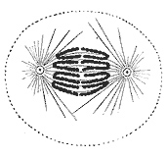 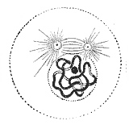 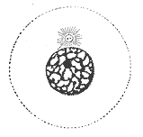

A B C

* 1. List the diagrams (A, B, C) in the correct order for the process of mitosis.

|  |  |
| --- | --- |
| **Description** | **Marks** |
| C, B, A | 1 |
| **Total** | **1** |

* 1. Identify the missing stages and draw diagrams to show what would be occurring in each of the missing stages.

|  |  |
| --- | --- |
| **Description** | **Mark** |
| Metaphase | 1 |
| Metaphase.jpg | 1 |
| Telophase | 1 |
| Telophase.jpg | 1 |
| **Total** | **4** |

**Question 15 (4 marks)**

Explain two events that can occur during meiosis that will produce gametes with different genetic content.

|  |  |
| --- | --- |
| **Description** | **Marks** |
| **Any two from the following:** | |
| Crossing over/recombination  Any one of:   * + - * Exchange of genetic material between homologous/pairs of chromosomes       * Chromatids may break and reattach to a chromatid of a different chromosome | 1  1 |
| Non-dis-junction  Any one of:   * + - * Homologous/pairs of chromosomes fail to separate       * One daughter cell receives more chromosomes than the other | 1  1 |
| Independent/random assortment  When cells divide during meiosis, homologous chromosomes are randomly distributed during (anaphase I), separating and segregating independently of each other | 1  1 |
| **Total** | **4** |

**End of Section 2 – Turn over for Section 3**

**Section 3: Extended answer (12 marks)**

This section has one question. Write your answers in the spaces provided.

______________________________________________________________________________

**Question 16**

DNA is sometimes called the “Code of Life” as it contains all of the information that makes us who we are. One of the most important tasks that DNA performs is the production of proteins.

Briefly describe the structure of DNA, and then explain the process of protein synthesis. Ensure that you are using the correct terminology, and explain where each step takes place. You may include diagrams in your explanation.

|  |  |
| --- | --- |
| **Description** | **Marks** |
| **Structure of DNA – Any three from:** | |
| double helix | 1-3 |
| complimentary base pairing |
| A and T G and C base pairs |
| Base pairs held together by hydrogen bonds |
| Sugar, phosphate molecules & nitrogenous bases |
| Nucleotides |
| **Process of protein synthesis – Any nine from:** | |
| Transcription | 1-9 |
| DNA unwound |
| DNA used as a template to make mRNA with complimentary base pairing |
| A and U, G and C |
| Enzyme RNA polymerase |
| RNA moved through nuclear pore to Ribosome/cytosol/RER |
| Translation |
| mRNA joins to ribosome |
| tRNA places correct amino acid following complimentary base pairing |
| tRNA joined to amino acid before (1 mark) Triplet codon/anticodon matching A and U, G and C |
| Bonds (peptide bonds) formed between the amino acids |
| tRNA detaches |
| and ribosomes move to next triple base (codon) |
| **Total** | **12** |

**END OF TEST**